Media Services with ORM Stack

Contents

1. Introduction 3
2. Workflow diagram to deploy the stack 3
3. Create stack for the Media Services 4
4. Plan the Job 7
5. Apply the Job 8
6. Verify in the Console 9
7. Destroy the stack 10

Introduction
The Oracle Cloud Infrastructure (OCI) Media Services is a fully managed service for processing media (video) source content. It provides scalable distribution and origination for just-in-time packaged Adaptive Bitrate (ABR) video content. The OCI Media Services includes OCI Media Flow and OCI Media Streams. The services can be used independently or together and operate on the content stored in the OCI Object Store.

OCI Media Flow enables you to configure content processing workflows that can be used to process video source content. The processing includes transcoding, transcribing, thumbnail generation, ABR packaging, and integration with OCI AI Services such as Speech (for automatic transcription), Language (for Natural Language Processing (NLP) based analysis of the transcript), and Vision (for object detection and text extraction).

Workflow diagram to deploy the stack
Below diagram shows how the Terraform Artifact are applied in the OCI. While creating a ORM stack, using terraform deliverables Init, Plan and Apply is the flow to provision the resource in the OCI. We can have the deliverables in any of below.
- GitLab/GitHub Repo
- Bitbucket
- Can be in folder/.zip in the local disk
- Object Storage Bucket
- Can be in compartment
- Oracle provided Template


Create stack for the Media Services

Go to OCI Console Developer Services Resource Manager Stacks select the compartment Create Stack

My Configuration Folder Browse Select the “Media Services” folder that contains the terraform Upload

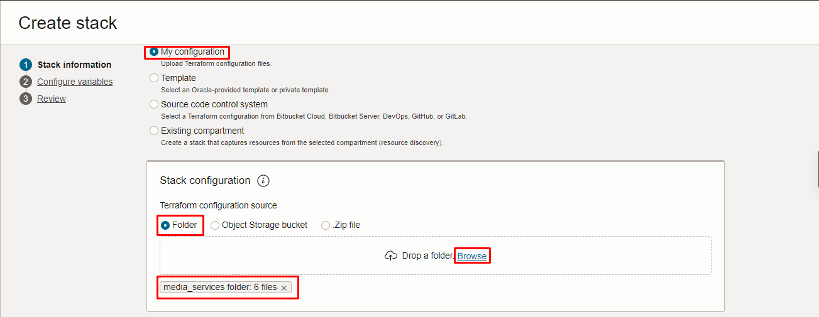

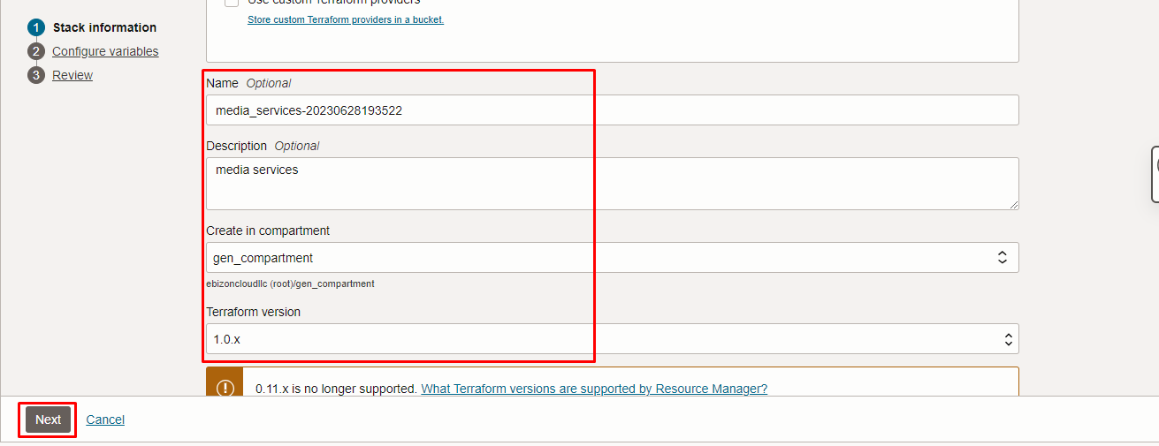
Click “NEXT”

Select the parameters as per the below screen,

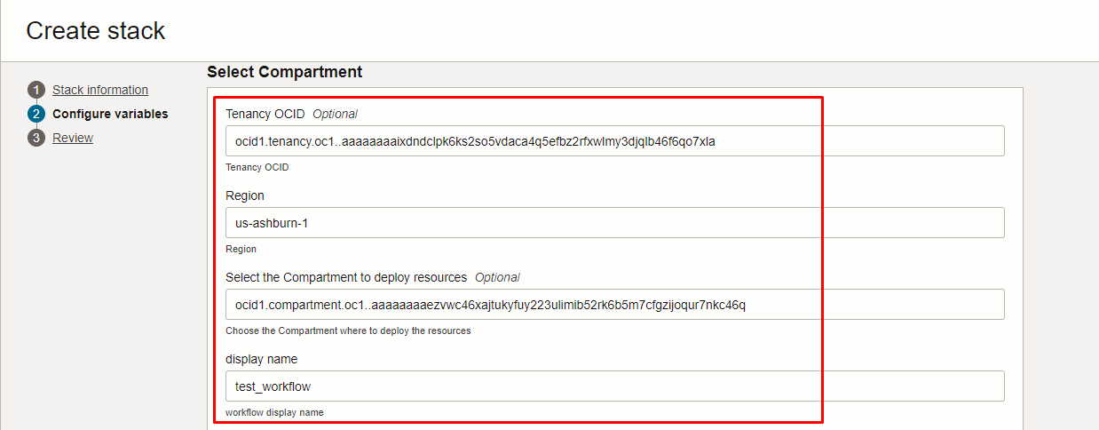
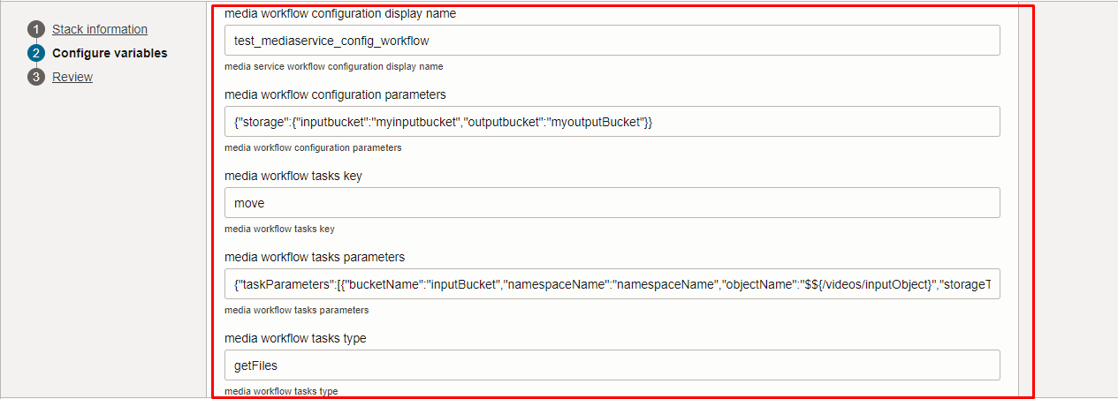
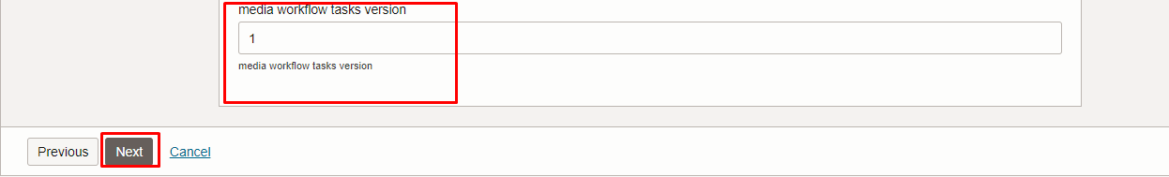
Click “NEXT” Click “CREATE”

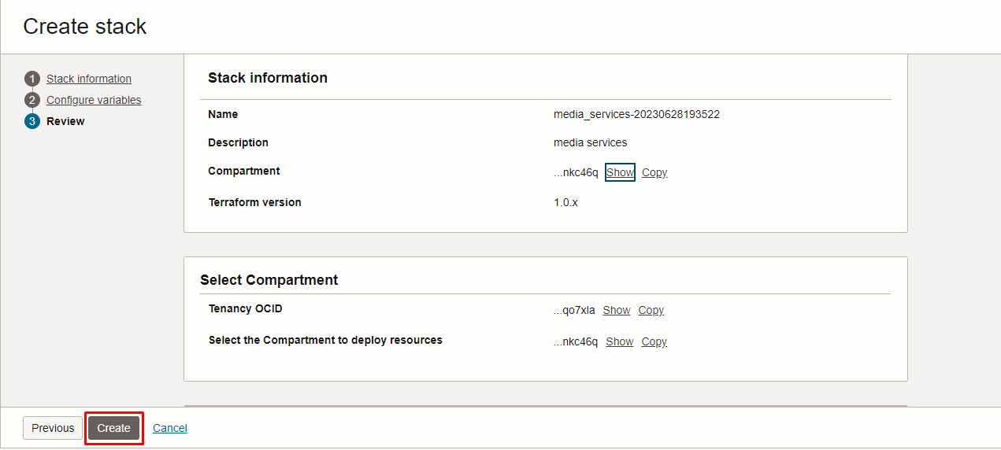

Plan the Job

Click the “Plan”

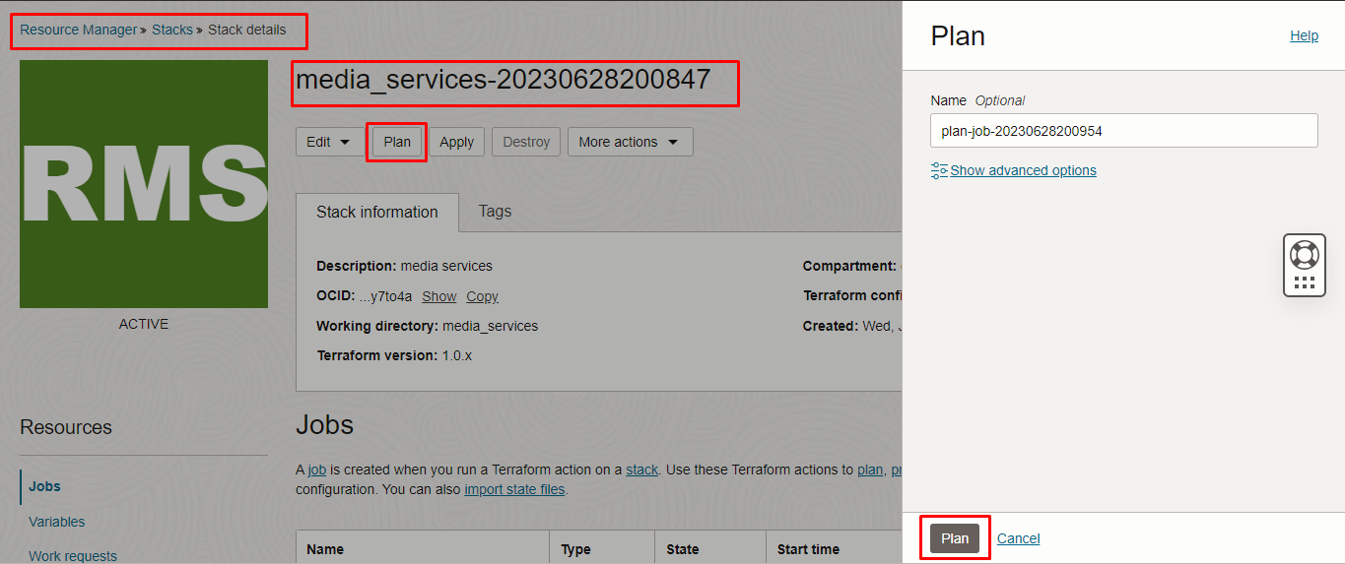
Verify the Plan is successful.

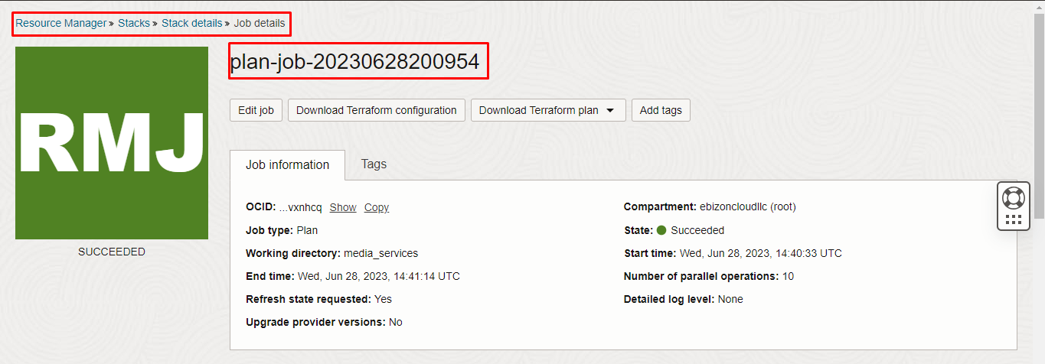
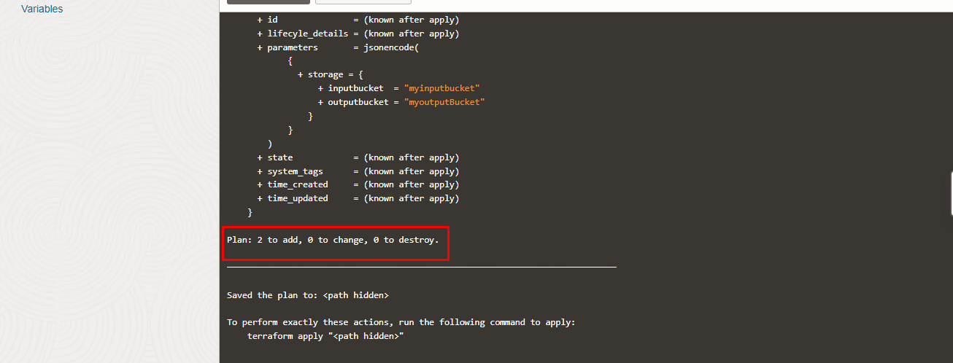

Apply the Job

Once the “plan” is success, now click “Apply”
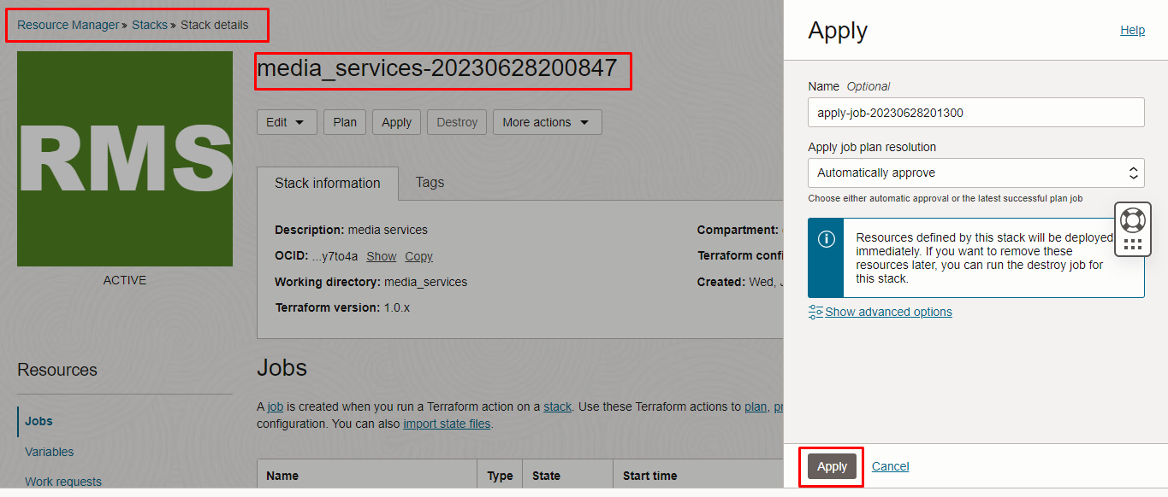
Verify the Apply is successful.

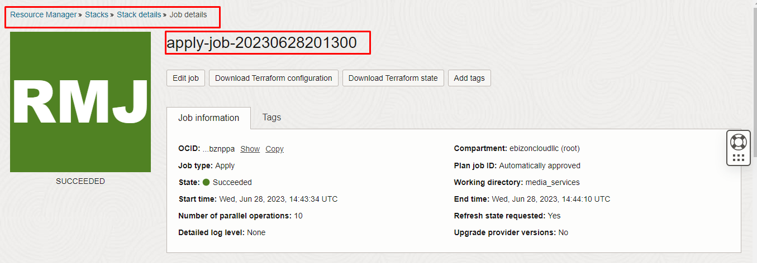
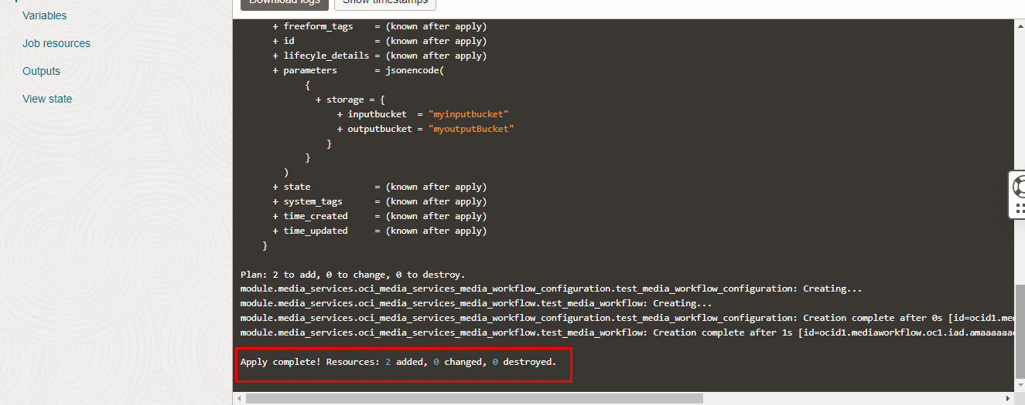

Verify in the Console

Go to OCI Console Analytics & AI Media Services

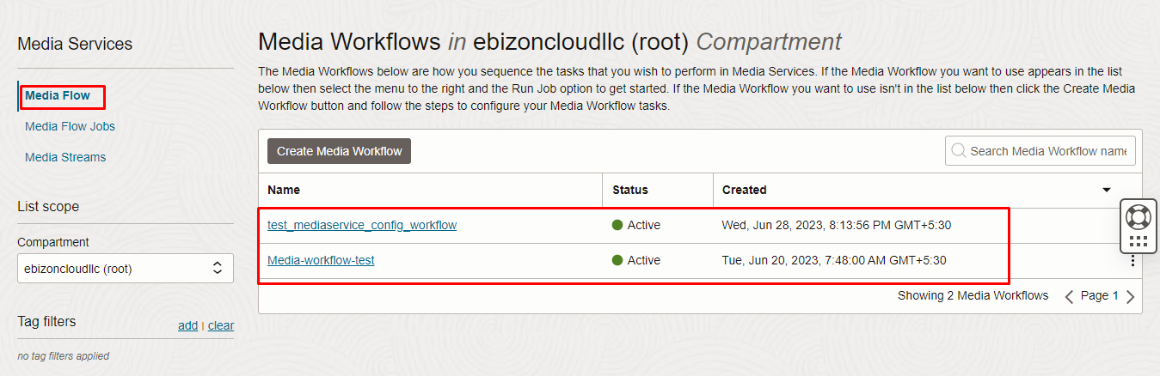
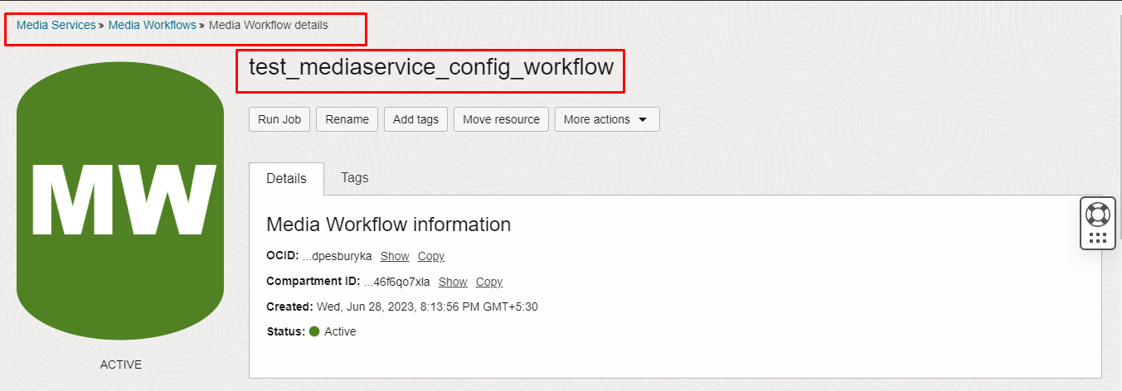
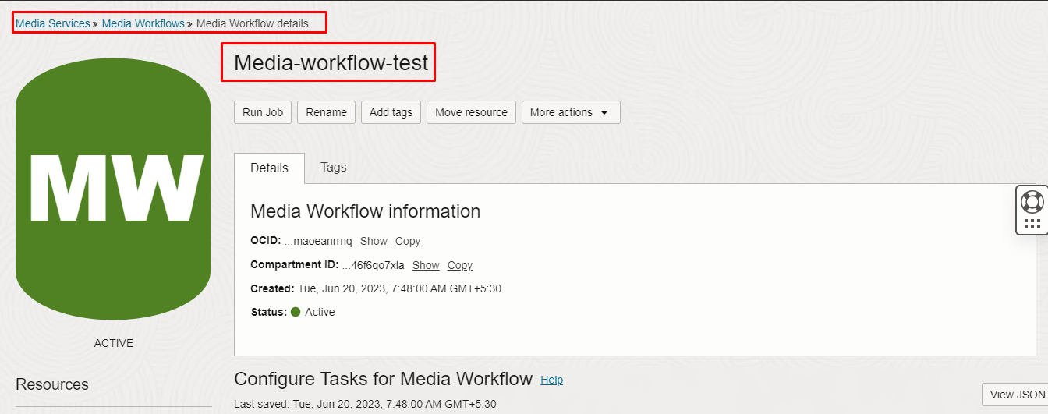

Destroy the stack

Create a destroy job in Resource Manager to release resources associated with a stack and clean up the tenancy. Once destroyed data cannot be recovered from resources.

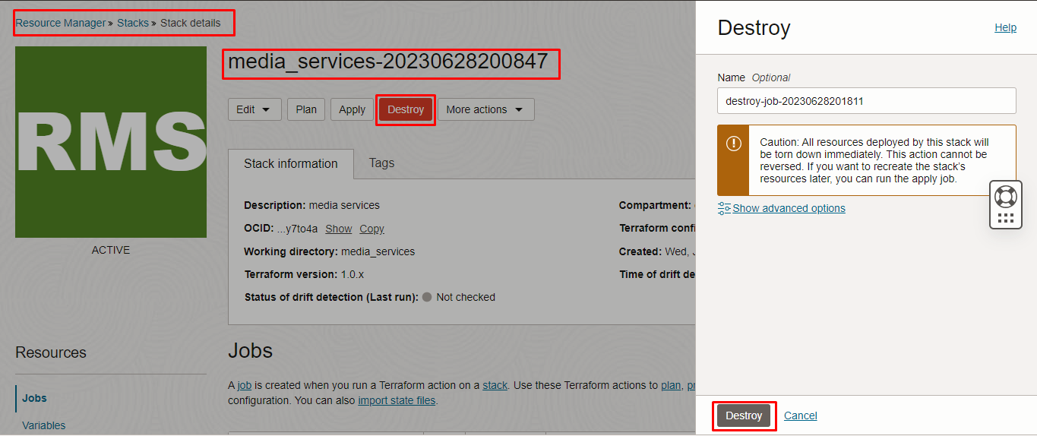

###########END###########

